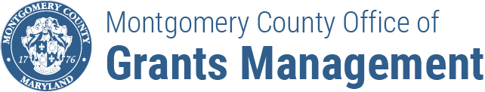
FY24 ENHANCED MOBILITY
GRANTS PROGRAM
APPLICATION CHECKLIST

Check whether your application is complete after completing it and prior to submission.

- HAVE YOU SUBMITTED ALL REQUIRED DOCUMENTS AND CHECKED WHETHER YOU UPLOADED THE CORRECT ATTACHMENTS?

☐ | IRS Tax Exempt Determination Letter
☐ | Most recent form 990/e-Postcard
☐ | Current board list with names, affiliation, and contact information
☐ | Project Narrative
☐ | Project Budget and Budget Narrative
☐ | Project Outreach Plan
☐ | Project Work Plan/Timeline
☐ | Performance Plan

- ARE YOUR APPLICATION MATERIALS RESPONSIVE TO THE NOFO REQUIREMENTS?

☐ | The Montgomery Funding Request matches the total budgeted amount in your budget
☐ | Your budget clearly delineates capital and operating expenses and contains detailed cost information for the proposed expenses
☐ | Your overall funding request DOES NOT exceed $105,000. The capital expenses, if any, are no more than $65,000. The operating expenses, if any, are no more than $40,000
☐ | Your budget narrative clearly explains the purpose of the expenditures and how costs were calculated
☐ | You demonstrate capacity to manage a cost reimbursable award AND/OR confirm that you will have sufficient financial liquidity to manage a cost reimbursable award (does not apply to awards $20,000-$25,000 with ONLY operating expenses)

