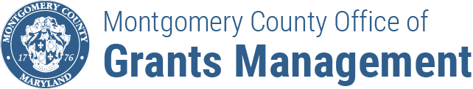
FY24 ENHANCED MOBILITY
GRANTS PROGRAM
SHOULD YOU APPLY?

Check whether you are eligible and ready to apply by completing this checklist before starting an application

- DO YOU MEET THE ELIGIBILITY CRITERIA?

☐ | Your organization has a Federal 501(c)(3) tax-exempt status
☐ | Your organization is in good standing with SDAT
☐ | You have a CVRS number
☐ | If your organization is currently implementing a Montgomery County contract or grant, you are current on all reporting obligations

- DO YOUR PROPOSED ACTIVITIES FIT WITHIN THE SCOPE OF ACTIVITIES TO BE FUNDED AS DESCRIBED IN THE NOFO?

☐ | All activities and expenditures under your grant are in Montgomery County OR are exclusively for Montgomery County residents
☐ | Proposed expenses are for a new activity, expansion of existing activities or a combination of both.
☐ | You plan on submitting only one application
☐ | Your project targets one of the following populations: individuals with physical, emotional, and/or intellectual disabilities; seniors 63 years old and older (same eligibility for MCDOT’s Call-n-Ride Program); individuals with limited incomes aged 18-62; other vulnerable populations residing in Montgomery County, specifically in underserved communities

